**OCR PROGRAMMING PROJECT (Component 03)**

* + **Candidate name: Henry MASTERS**
  + **Candidate number: 8103**
  + **Centre number: 51427**
  + **Centre name: Upton Court Grammar School**

**CHAPTERS: Ignore this, skip to next contents page (this is for referencing)**

* ***Analysis:***
  + ***Problem Identification***
  + ***Stakeholders***
  + ***Research***
  + ***Essential features***
  + ***Limitations***
  + ***Solution Requirements***
  + ***Success Criteria***
* ***Design:***
  + ***Decomposition***
  + ***Define Structure***
  + ***Algorithms***
  + ***Usability Features***
  + ***Variables, data structures & validation***
  + ***Iterative development test data***
  + ***Post development test data***
* ***Development:***
  + ***Development Evidence***
  + ***Prototyping***
  + ***Code Modules***
  + ***Code comments***
  + ***Variables/structure names***
  + ***Validation***
  + ***Reviewed***
* ***Testing (Developmental):***
  + ***Testing Evidence***
  + ***Failed tests***
* ***Testing (Evaluative):***
  + ***Final testing evidence***
  + ***Usability testing***
* ***Evaluation:***
  + ***Evaluate success criteria***
  + ***Evaluate usability features***
  + ***Limitations & maintenance***
  + ***Evidence, structure & relevance***

Table of Contents

Analysis 5

NEA brainstorming: 5

Decision: 2D Metroidvania 6

Problem Identification 7

Computational methods 7

Thinking abstractly & Visualisation 7

Thinking ahead 7

Thinking procedurally/ Decomposition 7

Thinking logically 7

Thinking concurrently 8

Backtracking 8

Pipelining 8

Stakeholders 8

RandomEF ltd. – Primary stakeholder 8

*JONDAL*© - Secondary stakeholder 8

Forge & Co. – Secondary stakeholder 9

PoochEdMasters ™ - Secondary stakeholder 9

Delta & Sons – Tertiary stakeholder 9

Research 10

Hollow Knight 10

*Celeste* 10

New Super Mario Bros. 11

Undertale 11

Essential features 12

Limitations 12

Solution requirements 13

Success criteria 13

Design 14

Decompose problem 14

Define Structure 14

Algorithms 14

Usability features 14

Variables, Data Structures, Validation 14

Iterative Development Test Data 14

Post Development Test Data 14

Development 14

Basic player movement & a basic level 15

Crouching 24

Global variables 25

First enemy & level revamp 25

RandomEF ltd. interview 27

Combat 30

Healing 34

Combat – enemies 35

Camera limits – version 1 37

Zone switching 39

Adding to the environment – part I 41

Checkpoints & Respawn revamp 44

Revamping the camera system 46

A new enemy 47

SFX 49

Forge & Co. Interview 49

NPC & Dialogue 50

UI - lives 62

Potions – healing revamp 66

Chest(s) 67

Map expansion 69

Bibliography: 71

# Analysis

## NEA brainstorming:

* 2D platformer/metroidvania (dead cells-esque combat?)
* 2/3D First person shooter (3D using 2D engine? Or 3D using 3D)
* Puzzle game (integrate puzzles into metroidvania anyways)
* Game engine

Engine:

* Unity:
  + Pros: Myriad resources, easy to learn, powerful
  + Cons: Uses C#, it’s unity, may run slow on my equipment
* Unreal:
  + Pros: Same as unity, except more powerful for 3D
  + Cons: Uses C++, very intensive on hardware, not great for 2D
* Godot:
  + Pros: Very lightweight, fast-growing community + resources, very easy to learn
  + Cons: Uses gdscript, unfamiliar workflow, may be difficult to paste code into doc

|  |  |  |  |  |
| --- | --- | --- | --- | --- |
| **Idea** | **Explanation** | **Language** | **Complexity** | **Computational Methods** |
| **2D platformer/metroidvania** | **Users play as a character exploring different regions with platforming sections, enemies and boss fights** | **GDscript** | **Player movement must be tight, enemy AI, difficulty scaling, GUI, database for various user files on one application** | **Concept is impossible to replicate in real life, decomposition for environments, enemies, etc., mixture of OOP and procedural programming** |
| **2/3D first person shooter** | **Users play as an unseen character (first person view) with a gun; arcade style levels with progressively harder difficulty** | **GDscript** | **Rendering 3D environment with enemies, player physics, enemy AI, database for different user files and leaderboards** | **Decomposing basic elements (shooting, enemies, etc.), abstracting enemies to classes, mix of OOP and procedural programming** |
| **Puzzle game** | **Users are presented with many puzzle levels, possibly featuring odd perspectives/ geometry** | **GDscript or python (and pygame)** | **Logic behind puzzles, integrating unique edges to puzzles, database for user files and leaderboards** | **Decomposing user inputs, abstracting puzzles (e.g., only solutions, add wrong solutions later), mix of OOP and procedural programming** |

## Decision: 2D Metroidvania

I chose the 2D metroidvania as I believe it has just the right amount of complexity for the project scope and my personal fulfilment. The puzzle game would have likely become too simple, as even more complex puzzles (such as ones that use isometric, forced perspectives e.g., Monument Valley) are relatively not complex enough for the project. The first-person shooter game may have been complex enough for the project, as there are an array of components I could have possibly used, however the concept did not personally appeal to me enough to wish to spend so much time developing it. The 2D metroidvania, on the other hand, is a project I have wanted to develop for a long time, and the NEA seemed like the perfect opportunity to give it a go. Furthermore, the game will easily reach the necessary complexity due to the myriad components that comprise a metroidvania, so that will not be an issue.

# Problem Identification

## Computational methods

### Thinking abstractly & Visualisation

* Abstraction will play a key part in my game, as many of the mechanics behind the scenes either will not need to be shown to the player or can be displayed in a different way to how they are implemented
* For example, the code for the player’s health will be determined by numbers, however rather than displaying a number on the player’s screen I will instead use a symbol (such as hearts) for the player to visualise and understand their lives with
* I will also ensure that all state changes are clearly indicated, for example the enemies will have an animation play when damaged, so the player can instantly tell when they have hit the enemy
* Another example is the player’s movement; the physics will be very different to actual reality, based in what is fun as opposed to what is realistic. This is because it is unnecessary for the game to have super-realistic physics, and would instead detract from the game’s overall feel and playability

### Thinking ahead

* The main aspect of my game that will need to be thought ahead are the player inputs. I will need to decide which keys the player should press for certain actions e.g., movement, attacking and these will need to be implemented before the player enters the game

### Thinking procedurally/ Decomposition

* Almost all my code will be written using procedural programming, so thinking procedurally will be integral to my game’s design
* For example, some functions will need to call other functions, and I will need to keep track of what code runs where and ensure everything runs smoothly without error (such as stack overflow errors)

### Thinking logically

* In some areas of my code, there will be a lot of conditional variables that must be checked before executing certain code, and I will need to think logically to know where to check such conditions
* For example, if the player is in the “dead” state, they will not be able to move, so all the movement code can be under one if statement checking that variable regardless of the separate conditions certain aspects of movement need

### Thinking concurrently

* Games function almost entirely through concurrent processes, as a number of things must happen simultaneously for them to work properly
* For example, in any given scene, the screen must be rendered every frame, the player’s inputs must be checked, the enemy’s decisions must be made in terms of movement, etc.

### Backtracking

* I frequently make use of backtracking in my style of software development, as I often implement systems, and return to them later to alter them wherever I feel they need to be changed

### Pipelining

* Pipelining will not be the most prevalent feature of my game; however, I do plan to use it in certain areas such as unlocking regions when the player executes a certain task, or a specific variable is updated etc.

# Stakeholders

I have five shareholders: RandomEF ltd., JONDAL©, Forge & Co., PoochEdMasters™ and Delta & Sons. RandomEF ltd are the overarching stakeholder, who own the other distribution networks.

## **RandomEF ltd. – Primary stakeholder**

RandomEF ltd are a small videogame publishing company established in 20XX. My primary communications with the company will be with CEO “Eshan Fadi”, an avid gamer with an affinity for metroidvanias such as “*Hollow Knight” (*Team Cherry) and platformers such as “*Celeste” (*MaddyMakesGames). They will be looking at my overall game quality, and backend code.

## ***JONDAL***© - **Secondary stakeholder**

JONDAL are a well-established publishing group, formed in 19XX. My primary communications with the company will be with president “Jonathan Dalton”, a gamer who enjoys a variety of games, from metroidvania “*Aeterna Noctis*” to sprawling RPG “*Baldur’s Gate III*”. As Jonathan has a partiality to RPGs, he will be looking at my story, characters, and feel of the game.

## **Forge & Co. – Secondary stakeholder**

Forge & Co. are a refined establishment that aim to help developers and please the players with their published games. Their next project, “_____” (my game) is funded primarily by Rory Graham, who is excited to publish the company’s first metroidvania with ______ (me). He, being the solo man behind the team, hopes that the game will live long, and prosper on the Steam marketplace. “YOLO” – Rory Graham. Rory enjoys a wide variety of games, so he will be assessing the overall quality of my game, and as a musician he will also evaluate the soundtrack of my game.

## **PoochEdMasters ™ - Secondary stakeholder**

PoochEdMasters, ran by eager gamer “Edward Masters”, one of the most famous publishers in the industry, known for titles such as the platformer “Fantastic Francesca Sisters”. Usually known for multiplayer games, PoochEdMasters decided to broaden their horizons with a 2D metroidvania. Mr. Masters firmly believes this will elevate the company, and will expand their demographic raising profits by a projected £10bn+. In Ed’s words, “erm.. what the sigma?” Ed is an enjoyer of art in gaming, so he will be assessing the sprites used in my game.

## **Delta & Sons – Tertiary stakeholder**

Delta & Sons are a staple in the game journaling industry that are eager to see the direction my game takes. They are led by president “Delawar Shamim”, who will handle my primary communications with the company. Shamim has expressed wishes to assess the sound effects of my game, so he will be evaluating the implantation of SFX into my game. I will also by working with “Affan Khan”, from the RWhite branch of Delta & Sons, who enjoys a wide variety of games such as “Elden Ring”. He will be approaching my game as a regular customer, and so will give holistic feedback.

# Research

## **Hollow Knight**

Hollow Knight is a 2D metroidvania game by Team Cherry. My game takes a lot of inspiration from the game, particularly in terms of level structure. For example, here is the map from hollow knight:

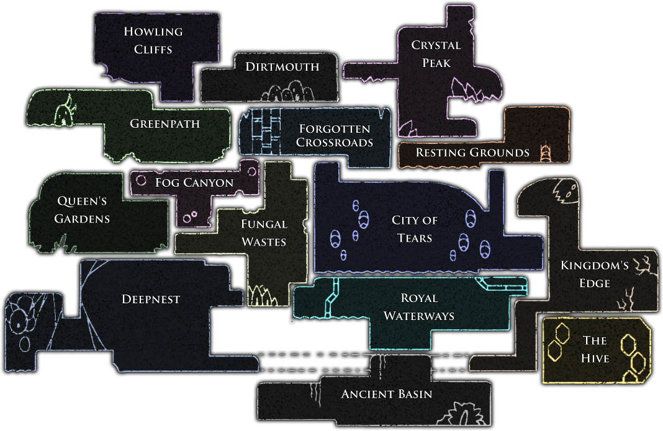

Compared to my sketched concept maps:

[__________]

As you can see, there are a lot of similarities between my map and hollow knight’s – not in terms of scale of course, but in generic structure. Hollow Knight’s combat system also seeps into mine, with its simple nail system being a large inspiration for how I attempted to integrate combat into my game.

## ***Celeste***

Celeste is a 2D platformer by MaddyMakesGames. This game primarily inspired the art direction I chose for my game, as Celeste uses a retro, 16-bit style that is elevated by modern tools to look fantastic in the contemporary gaming sphere. Here is a snapshot from Celeste:

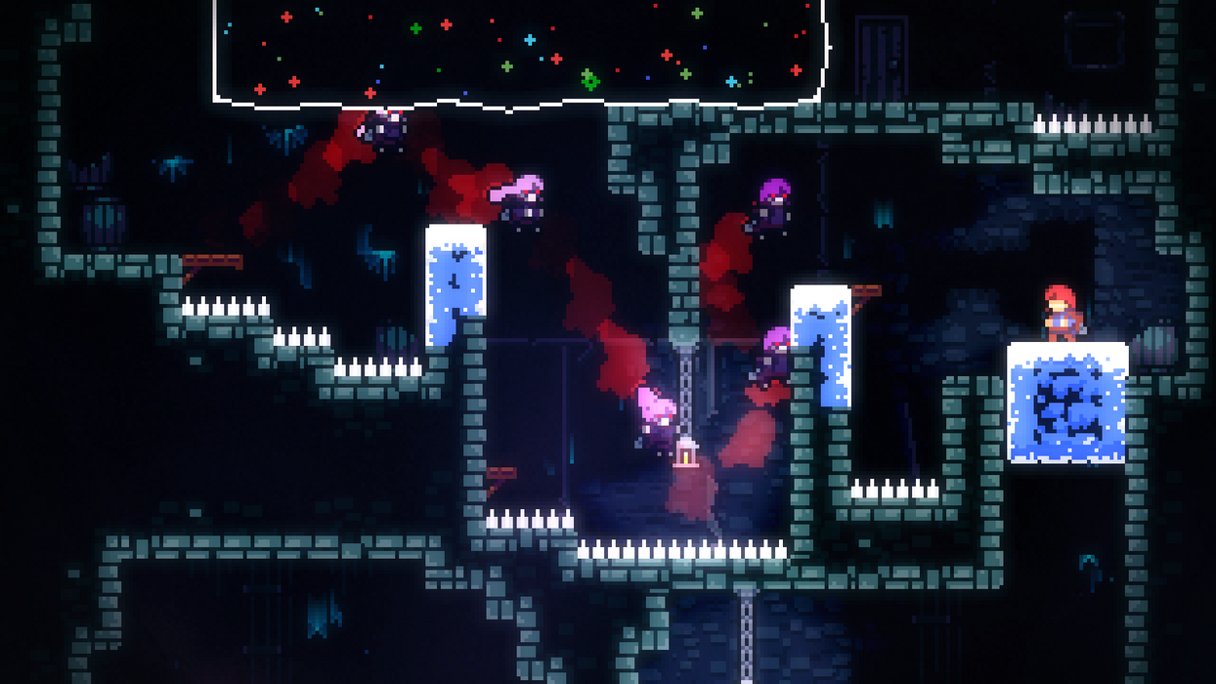

## **New Super Mario Bros.**

New Super Mario Bros. (hereafter NSMB) is also a 2D platformer, however it is unique on this list as it is the only AAA game, published by industry giant Nintendo. I decided to look at NSMB as it has near-perfect platforming elements and movement, making it a good case study to understand what makes a level good, and how to make movement feel fluid and controlled; I also have a DS with a copy of the game which helps. From my research, I found that the best levels had X in common, which led me to implement Y into my game.

## **Undertale**

Undertale is a 2D RPG by Toby Fox, that uses bullet-hell style gameplay during combat. Undertale is a staple in the indie game cultural zeitgeist, and for good reason. It has a compelling story, unique game mechanics (particularly with its karma system), enjoyable gameplay and most importantly, it is funny. Although not a platformer or metroidvania, Undertale inspired a lot of my game’s more bizarre elements, and dialogue.

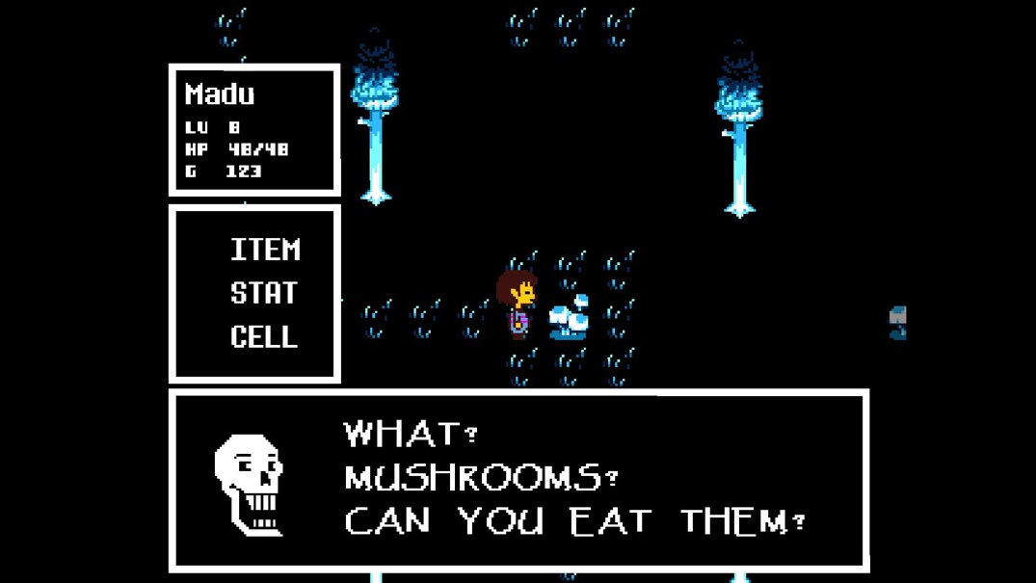

# Essential features

One of the most vital features of a good metroidvania is variety. My game will need to have a plethora of enemies to fight, each with their own unique move sets and sprites.

Another core feature will be the movement; platformers, and by extension metroidvanias, need tight movement to ensure the player always feels in control, especially as levels get harder.

My game also needs exciting bosses, that will cap off each major territory – they will need unique move sets, albeit perhaps just very altered versions of enemies in their respective zone.

Sound design will also need to be rather crisp for cohesion, as sound effects and music drastically impact the feel of a game, so I will need to keep that in mind when adding them in.

# Limitations

The main limitation I will face is time. Metroidvanias are known for their large, sprawling environments, which simply take too much time for the parameters of my NEA.

I am also new to the Godot engine, so there will be some learning needed to adjust to a new workflow and environment, and learning GDScript.

I have never made a full game before, and so I will need to be careful in regards to scope creep, as I could very easily start creating a project/ aspects of the project that will take far too long for the relatively short time frame I have to create this project.

# Solution requirements

The final solution will need to have the following:

* Smooth movement
* Interesting, varied enemies
* A large, fully explorable environment
* Cohesive environments
* A consistent storyline
* Minimal to preferably no bugs

# Success criteria

Ideally, I will provide a cohesive experience that the player will be able to enjoy without any interference – therefore, I aim for players to be able to learn all aspects of the game without asking me (or other players) questions such as “How to do X”, so once I am finished I will give it to various play testers and count how many of such questions I get, and hopefully I will get less than 5 per person, but the closer to 0 the better.

I also need to ensure that players will never run into issues such as bugs, and softlocks (a softlock is where the player gets stuck in a certain area of a game, and physically cannot escape or progress further). Regarding bugs, I will need to meticulously ensure that all my code runs how I want it to, and I, with the help of the play testers, will need to test as many if not all possible outcomes to different situations to see if certain actions cause issues. As for softlocks, I need to ensure the player can never get locked in a certain room or zone, as that would mean they would need to reset their game, which is incredibly unfair and creates a poor player experience. I will receive input from alpha and beta testers after small releases, and I will keep note of all reports of softlocks and bugs. I will need to thoroughly check reports of softlocks however, as sometimes on internet forums players will falsely claim they are locked in a certain area, when they actually need to just explore other regions or unlock a certain ability etc.

To measure player satisfaction, I will give play testers a Microsoft form that will include various questions to provide qualitative and quantitative data – one question will be a simple enjoyment scale from 1 to 7 (not 10, as I have noticed in the past that people answer scales from 1-10 with a lot of 7s as an almost stock answer, which does not indicate much in terms of actual opinion). I will also allow them to give general feedback, feedback on each zone, and what they would add/ remove in a series of scale-based questions and word-based questions.

# Design

## Decompose problem

## Define Structure

## Algorithms

## Usability features

## Variables, Data Structures, Validation

## Iterative Development Test Data

## Post Development Test Data

# Development

## Basic player movement & a basic level

The movement of the player in the game is comprised of multiple parts: basic left/right movement, jumping, double jumps, wall jumps, and a dash.

I started with the basic player movement, which was fairly simple to create – Godot has a default script for player movement, that uses the 2D vector “velocity” to determine how fast the player moves, and the variable “direction” to determine which direction the player must move in. I began with the default code, however I quickly modified the code to get the player’s movement feel tighter and more controlled.

Here is the code I began with:

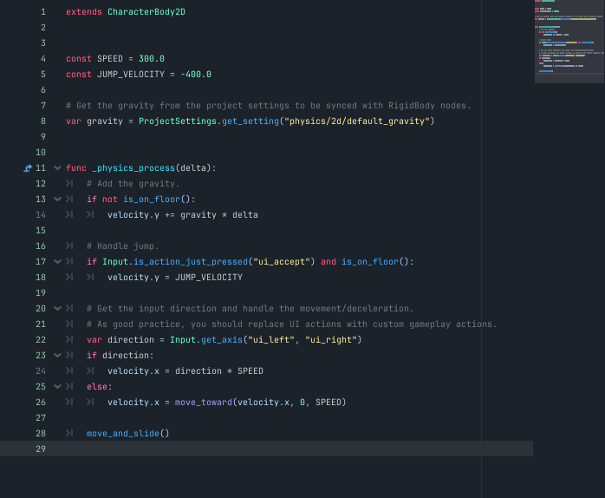

This code works, and the player can now move left, right and jump. However, this code makes the player feel incredibly floaty, which I will address later. For now, this will do whilst I implement the other movement components. [Note – I did change one element of this code very quickly; the values of the constants “SPEED” and “JUMP_VELOCITY” both get reduced between this iteration of the code and the next]

The next code I needed to implement was the movement animations. Whilst not explicitly to do with movement, it was vital I implemented these to better visualise my code. Below are the frames from each animation I created – the node “animated_sprite2D” automates the frame cycles, which I have shown below the sprites. All the player sprites are 16x16px, made in “LibreSprite”.

***The character:***

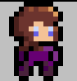

***Idle animation***

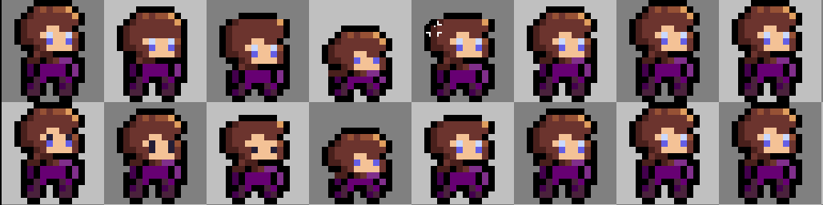

***Jump***

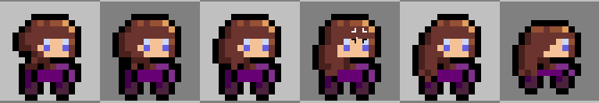

***Fall (Note – this is not used for a while)***

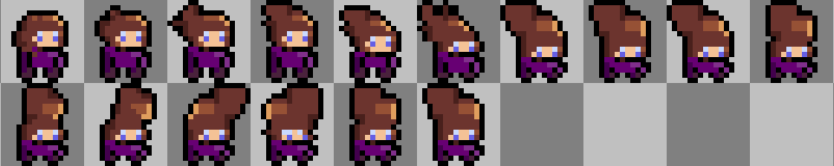

***Dash***

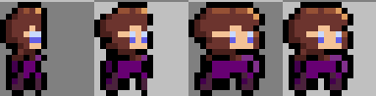

***Walk (This gets changed later – but it served its purpose)***

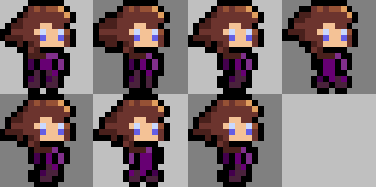

***Death***

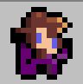

Before I move onto the rest of the player, I need to do something rather important; create a level for the player’s movement to be tested. Godot thankfully takes care of collisions, so I simply created a basic TileMap based on generic grass levels seen across various platformers, and created a simple level that would allow me to test all the necessary features.

***The TileMap***

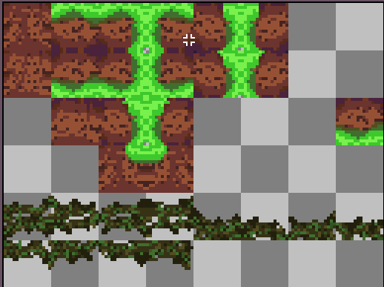

I want to quickly note – I did not know Godot had an in-built rotation feature for tiles. As you can see here, I ended up making the TileMap with this mindset, however all future TileMaps do not suffer from this issue.

***The level***

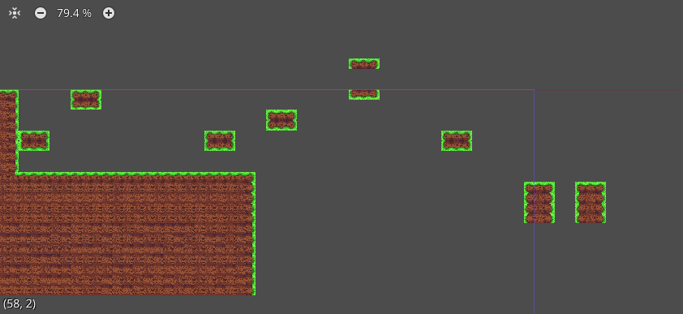

This is captured from the Godot preview menu, as the camera is zoomed in far more in-game.

Excellent! I now have a level to test my character in. However, there is one pressing issue; if my player falls off the level, they don’t die. To solve this issue, I created a Killzone node (initially based on Brackey’s Godot tutorial, linked in the bibliography), comprised of an empty area2D with a script attached – see below:

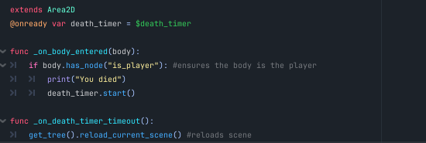

To ensure this only affects the player, I attached a blank node called “is_player” to the player’s CharacterBody2D node. This allows me to check if a colliding entity is the player, as seen in the above if statement. Currently, this script simply reloads the scene the player is when they enter the Area2D, so I added some extra script to make it slightly more interesting:

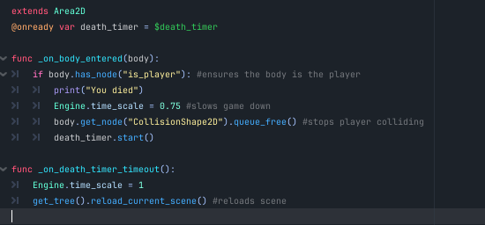

The game now slows down when the player dies, and removes the player’s collider, making them fall through the map.

Now that I had a suitable area to test my player in, I began working on the various movement components of my player, beginning with a dash. As a quick aside, before moving any further I placed all my movement code into a new function, which is still called during the *_physics_process()* function, but allows me to make neater, more readable code.

**Dashing**

The “dash” component of my player revolves around a simple premise: player presses a dash button, and the player gets boosted forward at a high velocity for a short period.

To make this work in a videogame setting, I had to establish a few variables. Firstly, I need to determine if the player is currently dashing, then I needed a dash timer, and finally the speed the player would dash at. Below are all these variables coded in:

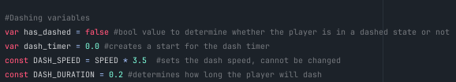

Using these variables, I ended up with this code here, for the basic dash:

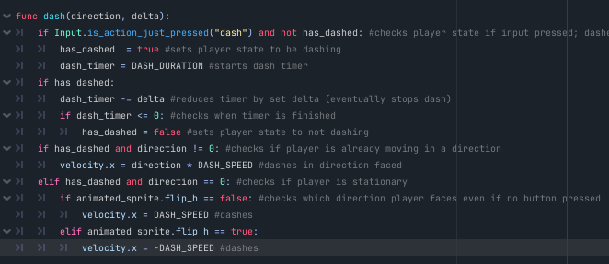

One part of the code I have not mentioned yet is the “animated_sprite.flip_h” bool expression; this simply flips the sprite, and I use this with pretty much every moving sprite.

This code is fully functional, however there was one issue. If the player spam-pressed the button to dash, they could go ridiculous distances as there was no cooldown to prevent such a situation. So I implemented a cooldown system, adding three new variables:

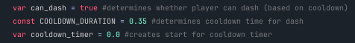

As you can see, these look very similar to the regular dash variables, and I used them in a very similar manner; the only difference being they prevented the player dashing rather than enabled the dash. Here is the code after implementing the cooldown:

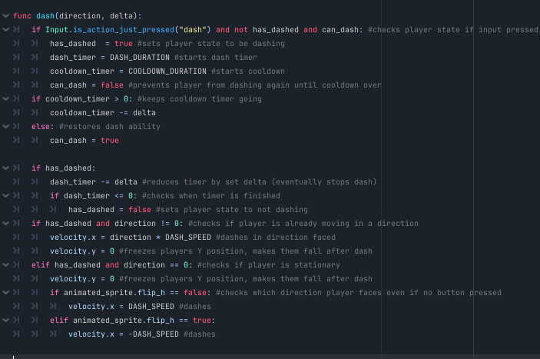

At this point, I was pretty much happy with my dash, but one thing I didn’t mention above is that I also implemented a small piece of code that froze the y velocity of the player to 0, so it felt tighter and reduced any floaty-ness to the dash (as you can see above). For now, this will do.

**Wall Jumping & Double Jumps**

This section will mainly focus on the wall jump mechanic I implemented, but I also decided to tack on the double jump feature as well since they both go hand in hand with each other.

Firstly, I added a double jump, which was relatively simple to implement. To do so, I simply created two new variables, “big_jumps” and “small_jumps”, that both reset to 1 when the player touched the floor. From there, I wrote this code:

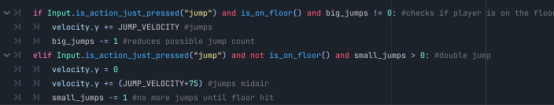

As you can see, if the player is on the ground and jumps, and they have a jump available (a slightly useless condition seemingly, but I wanted the ability to remove the player’s jump if I wanted to), they jump to the normal height, and can no longer jump. Then, if the player is in the air and jump, and they have a second jump available, their vertical velocity is reset, and then replaced with a slightly smaller jump in mid-air. Once they do one double jump, they must wait until they are on the floor before jumping again. I experimented with the height of the double jump for a while, until landing on 75 as an acceptable value.

Moving on to wall jumping, things started to get a lot trickier than anything up to this point. The first thing I did was to check if the player was on the wall. Thankfully, I found a method in Godot called “is_on_wall”, that, akin to *is_on_floor,* checks if the player is colliding with a wall. From here, I wrote a small if statement to give the player a second jump if they had already used it, when they collide with the wall. I did so using the “small_jumps” variable I had established with my double jump code. I also wrote a single line that slowed the player down; quite simply, it multiplied the regular gravity code by -0.25, so the player was only dragged down at 75% speed if sliding on a wall.

One issue I faced with wall jumping was checking where to launch the player if they were not holding a direction. To continue, I need to explain a very useful node in Godot, called a “RayCast2D”. Ray casts are colliders that can detect if they are colliding with something, and so if I attach one to my player, and make it face right, it can detect when it is colliding with a body to the right and send a signal to my code when it does. Here is what my ray casts look like on my player:

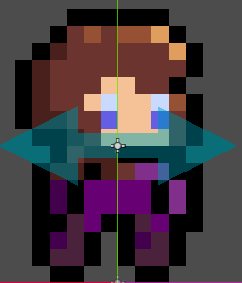

As they are attached to my player node, they move with the player, and allow me to now check if the player is colliding with a wall on the left, or the right.

From here, I wrote this code for the wall jump itself:

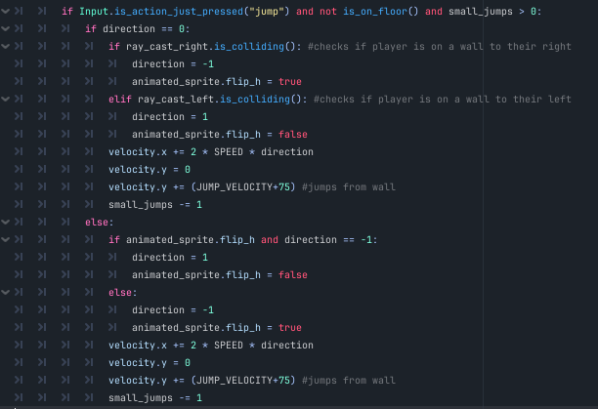

This almost worked. I say almost, however, as there was one thing I forgot to do; as with the dash, there was no cooldown for the wall jump, which did lead to some rather entertaining results. Due to the lack of any cooldown, once a player jumped off from the wall, they never slowed down. So I added a cooldown, with a timer node.

The final component I wanted to add was a way for the player to fall from the wall if they chose to. To do so, I simply checked if the player pressed down, and then shifted them according to their direction. Rather than ray casts, I simply checked the direction of their sprite. In hindsight, I should have used ray casts, but I wanted to move on so I left it as is. Here is the final code for the wall jump:

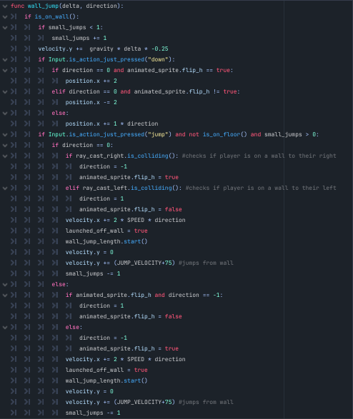

## Crouching

After the lengthy process of creating a wall jump, I wanted to implement a quick, small piece of code. This culminated in me creating a small crouch function, that simply changed the player’s animation. I may alter this in future to change the hitbox size of the player also, if I deem it necessary. The code:

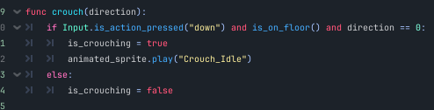

## Global variables

At this point, I realised I needed a way to communicate amongst different scripts with ease, and update variables across the entire project, rather than just one script. To solve this, I created a new script, not attached to any node, called “GlobalVars”, where I could now create variables that I wished to use in various scripts, such as the player’s health and damage. From here, most major scripts would make use of these variables.

## First enemy & level revamp

Now, I wanted to create an enemy for my player to avoid, because I had been working far too long solely on the player and I needed something new. I also decided that now would be a good time to properly create a level, as I had established most of the core elements of the player’s movement. Here are some concepts I drew up in a sketchbook for the tutorial area:

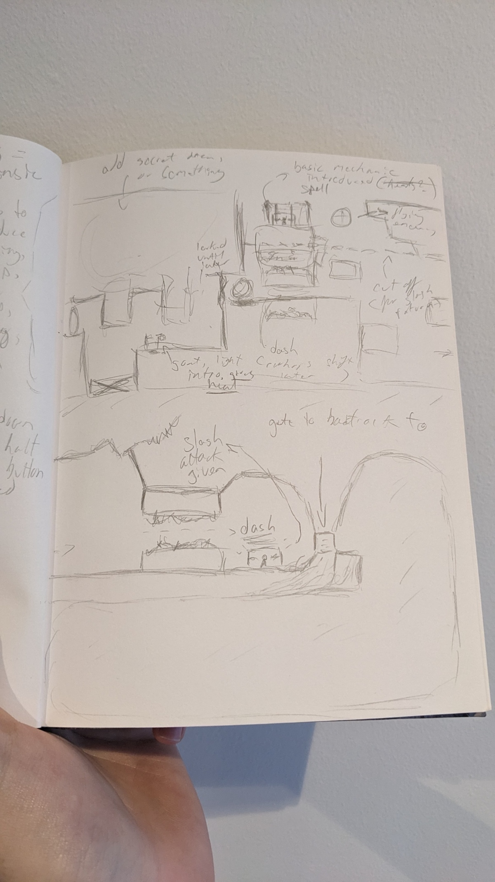

And then the area I created from these sketches:

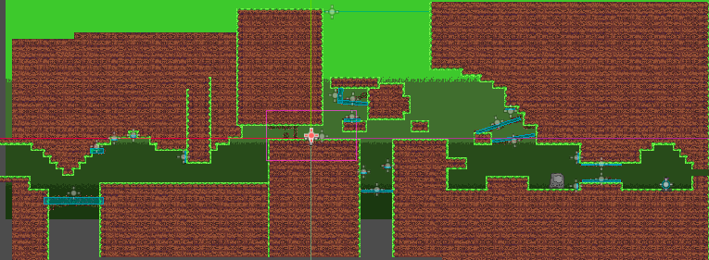

The blue rectangles you see encompassing the spikes are hitboxes. Rather than create spikes with hitboxes attached to them, I created a separate node for the hitbox, allowing me to adapt the hitbox to the shape of the spikes used in the scene, which uses less hitboxes than if I used on for each tile.

RandomEF ltd. interview  
For my enemy, I got a little stuck on the design, so I had a chat with one of my stakeholders, “RandomEF ltd.”. Here is a transcription of the key points in our discussion:

**Me:** Hey, Eshan. I am currently deciding on what my first enemy should be, I want it to fit the grassy theme of the level, but also not feel too derivative of other monsters/creatures found in gaming.

**Eshan:** Hmm. Have you considered basing the enemy in real life? Like taking a pre-existing animal and altering it slightly to fit your needs?

**Me:** Okay, that’s a good idea… Do you have any suggestions of an animal?

**Eshan:** Umm sure, maybe a goat or something?

**Me:** Sure! There’s a lot I could do with that actually.

From this conversation, as you can see, I decided to make a goat for my first enemy. Slightly unorthodox, but I rolled with it, and began to brainstorm mechanical ideas for the goat. Eventually, I decided that the main gimmick of the goat would be this: it walks around idly until the player enters its detection zone, at which point it becomes enraged (almost possessed by some malicious spirit) and charges towards the player, maintaining a higher speed until either killed or moved past by a significant enough area.

To get started, I had to establish a few conditions. Firstly, the goat must be in one of two states at any given moment: idle, or angry. Then, the goat must also not move when it is in the animation of becoming angry. To account for this, I first created an “angry” variable and an “in_animation” variable, both bool data types. From there, I also had to create variables for the main gimmick of the goat, being the detection system. To execute this, I created two area2D nodes around the goat; one that detected when the player entered it, and one that detected when the player left, both attached to variables “player_exited” and the aforementioned “angry”. I structured it as such as I wanted the goat’s detection of the player to have a shorter range than the player’s distance to exit, to make the fight more intense as the goat would stay angry longer once engaged with. I also added four ray casts to check if the goat was either colliding with a wall or if there was no floor in front of it, so it could turn and wouldn’t fall of the map. This resulted in this:

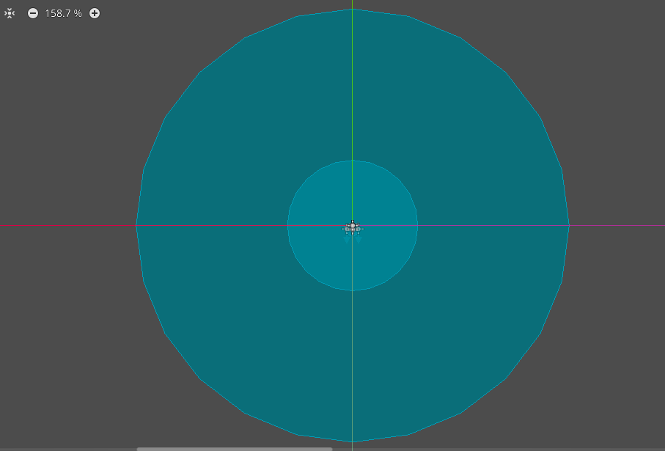

With the goat barely visible in the centre. As you can clearly see, the exit area is far greater, so the player must run very far away if they choose not to engage with the goat. This will mainly be prominent in future instances of the goat, since I plan to make the first encounter mandatory.

With the general framework established, I got coding, and ended up with this, for the goat’s movement and detection system:

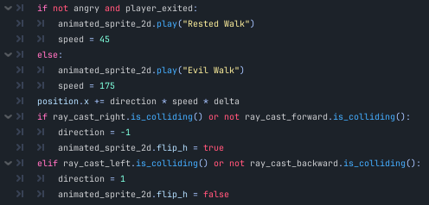

Now, the goat would walk from side to side, flipping from left to right when needed. To get the anger system working, it was quite simple. When the player entered the detection zone, a signal would be emitted and this script run:

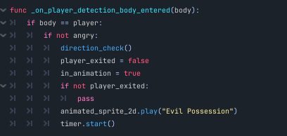

As you can see, the function calls another function (which I will touch on momentarily), sets the player_exited variable to false, and sets the goat’s state to be in_animation. It also passes if the player has currently not exited. It then plays the possession animation and starts a timer.

The direction_check() function simply checks the player’s position relative to the goat, and then flips the sprite to face the player. See the code here:

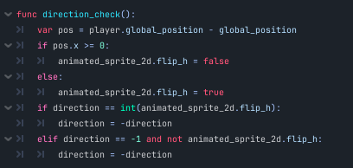

Once the timer is over, and the possession animation is finished, the goat gets set to angry, and in_animation is set to false.

When the player leaves the exit zone, this function is called:

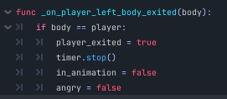

This resets the goat’s state to normal and stops the possession animation if it is running.

One odd bug I ran into whilst implementing the goat was that it seemed to start the game in an angry state, despite the variable angry being false by default. To counter this, I added a for loop that played the idle animation 10 times over that ran when the goat was loaded. A bizarre solution, but it worked nonetheless.

## Combat

Now comes one of the trickiest aspects of my game thus far: a basic slash. Despite being such a small feature, and my naïve estimate that it would not take long, implementing combat proved to be a rather tough challenge.

The concept is simple, the player hits the attack button, and a hitbox is instantiated in front of the player (or above if holding up) and any enemies inside the hitbox take damage. So, I started by creating the hitbox scene, which was a simple Area2D with a child Collision2D node that I moulded over time to create a hitbox for the attack.

The first thing I did was create a behemoth of an if statement that would check if the player met the conditions to attack, shown here:





The first condition simply checks if the player has pressed the attack button. For the next, I wanted to make it so the player could not attack until they obtained a sword (found in the tutorial level), so I created a Global variable “has_sword” to check for this. The third condition checks if the player is able to attack, as I put a cooldown on the slash system (having learned from my previous mistakes). The fourth ensures the player cannot attack on a wall. The next ensures the player is not dead, as I implemented the Global variable “is_dead” for this exact purpose; so the player cannot interact with the game post-mortem, until I implement a restart screen that is. Finally, the game ensures you are not trying to attack downwards, as I am still figuring out how I want to implement downwards movement and combat.

I then wrote some more basic (or what seemed basic) code:

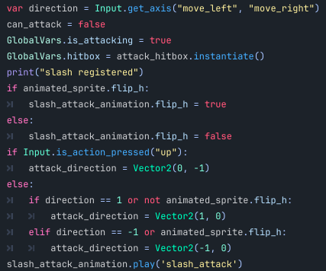

Since all my combat was in a separate *_input(event)* function I had to make a new direction variable, seen on line 1. Then, it updates some player states, and instantiates a new hitbox into the scene. The print statement is merely there for debugging, and it came in very useful when everything kept breaking later on. It then checks if the attack animation sprite should be flipped based on the player’s current sprite. Then, I set a separate “attack_direction” variable to be a Vector2 value to determine what direction the hitbox needs to go in relation to the player. The attack animation then plays.

The next piece of code checks if the player is accelerating upwards, and takes this into account with where the hitbox is placed:

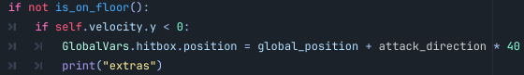

Again, there is a debug print statement, although this code rarely if ever created bugs, besides some early tests where I had not specified “self” for example.

The next piece of code created a large portion of the bugs that I faced with the slash attack:

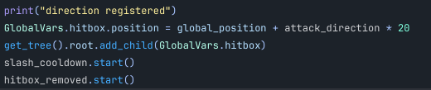

Despite being so small, this was like a minefield to walk through.

The console would often reach the print statement, so that meant everything previously was working. The next line just positioned the hitbox, so it never caused any issues. The next line, however, was a rather different story. In all fairness, it was not actually that difficult, but when getting it to work this caused a number of issues. Initially, I wrote “**add_child(GlobalVars.hitbox**)”, which when I mentally thought it through, would add the hitbox as a child to the player. Instead, it didn’t work. I looked through the Godot documentation to try and find an alternative solution, and eventually found the “**get_tree**” function – something I had actually used prior in the killzone, but had slipped my mind. So, I next wrote “**get_tree().add_child(GlobalVars.hitbox)”.** This also did not work, as the “**get_tree”** function would return null. After a lot of frustration, I finally managed to get it to work, by specifying to get the root of the tree. I was far from done though, as the timers brought new problems.

The slash cooldown worked just fine; but all it did was change some variables, so of course it did, there was nothing really that could break. What very much could, however, was the “hitbox_removed” function, pictured below:

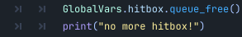

This, in theory, would work just fine. However, it quickly became a problem. Now, this was likely due to my previous implementation of the combat system. Before switching to the *_input()* function, the combat was written under the ­*_physics_process* ­function. This was, admittedly, a rather strange move on my behalf, but hindsight is 20/20. The issue came (at first) not from the code, but from the timer; it would restart every frame, and so it would never reach the end of it’s wait time. This resulted in hitboxes lasting, at times, forever. And you could make multiple at a time. This was not ideal, but eventually I discovered the *_input()* function, and so this issue was solved. But another arose. The error I had after this was very consistent, looking roughly like this: “error: tried to call func queue_free() on null instance”. I am still not too sure the exact cause of this error, as in theory a new hitbox should be instantiated on every attack, but it still happened. To solve this, I added a simple if statement, that ensured that the hitbox was not null. From here, no more bugs! Not for the player anyways. I then had to deal with the enemies, and how they would take damage. But first, I was exhausted from constant combat work, so I took a short break.

## Healing

As I mentioned, I was done with combat for a while. I had spent a good few hours straight attempting to get it to work, and I needed something nice and easy (sound familiar?). So, I decided to implement a simple healing function, linked to the new ­*_input()* function I had discovered. Here is the code:

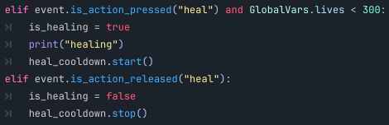

That’s it! It simply checks if the player is holding the heal button, and that their lives are below the maximum (it will not be 300 in the final product, 300 is for bug testing). It then sets the player state to be healing, and starts a cooldown timer, with a debug print statement in there for good measure. Thankfully, no major issues arose with healing. I also made it cancel the heal if the player lifted the button, an idea I shamelessly stole from Hollow Knight (although you won’t lose anything for cancelling your heal). On the timer’s timeout, the lives count goes up by 1.

## Combat – enemies

Back to combat. After I sorted out the player’s shenanigans, it was time to make the slash serve its purpose – do damage.

To do this, I learnt a nifty little trick of Godot, groups. Groups allow multiple nodes/scenes to be, well, grouped together. This was incredibly useful for me to get this to work, as I could now just check if the hitbox was colliding with something in the “enemies” group. This resulted in this tiny little code:

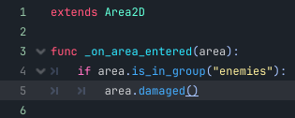

The way I implemented this uses a sort of pseudo object-oriented approach; if the area is in the group, it calls the function “damaged”, which means that for all future enemies they must take damage in the same way as each other, through a *damaged()*function attached to them, but the contents of the function could vary (similar to polymorphism).

Right now, there’s only one enemy in the game, the goat. In order for this setup to work, the goat needed a hitbox that would detect being attacked. I was tempted to just use the killzone hitbox, but since that already inherited from the killzone node, I decided to create a new Area2D node, and then I put that node in the “enemies” group. Attached to it, was this small script:

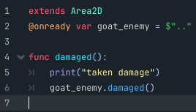

This script just called the goat’s *damaged()* function, which I will now discuss. The start of the function is very simple:

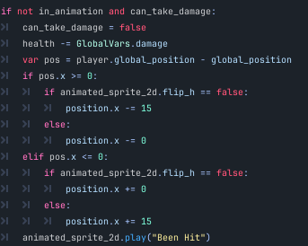

It ensures the goat is in the right state to take damage, and then if so immediately gives it immunity whilst being attacked. It then takes damage, and I used a Global variable to determine the value of damage as I plan to incorporate damage upgrades in future. The next few lines determine where the player is in relation to the player, and knocks it back if hit from the front. This took a fair bit of iteration to get working, as sometimes the goat would move backwards into the player when hit from behind, but in the end I ended up with this, that allows the player a little extra window of time to escape after dealing damage confrontationally. The sprite then plays the been hit animation. I had considered using the “modulate” parameter to merely shift the goat to red when hit, but I decided to create a separate animation for now as it was more familiar, and gave me more control over how it looked.

The next part of the function was very simple, and primarily dealt with the goat’s state, of either being hit/in animation or not. The been_hit timer would reset the in animation variable to false, and allow the goat to take damage again. The if statement below deals with the goat’s death, and updates a few bool states to ensure everything runs smoothly. Notably, the “dying” variable stops the goat from moving when dead, and plays the death animation. The death animation timer frees the goat from the queue after the animation has played. The killzone despawn timer is faster, and quickly despawns the killzone after the player kills the goat, as I did not want the player to be able to take damage from the goat after killing the goat. I may change this in the future, as it did cause some bugs, albeit rare, when the player died and killed it at the same time.

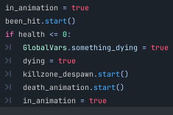

And that’s it for combat! From here I mainly focused on worldbuilding for a while, which comprised of various small updates here and there to start expanding my game, and making it feel more like a proper game than a tech demo.

## Camera limits – version 1

My first decision was to start making the camera feel a little better. I did this by creating various area2Ds that would move the camera in certain ways. I will show one example, as all other camera movements function in a similar manner, just variations on the same idea.

My camera started with a bottom limit of 100. This worked great for about 10 seconds, or however long you spent on the first platform height. However, when you walked to the right, the camera would be locked higher than the floor level, removing the player from view. To counteract this, I added an area2D near to the drop down point, and added this script, that lowered the limit so you could see the floor:

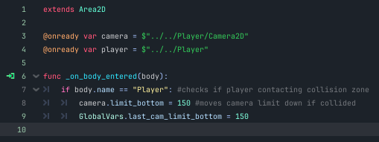

I also added another script that would raise the camera back up, and attached it to another area2D slightly left of the current one. This is what they look like in the editor:

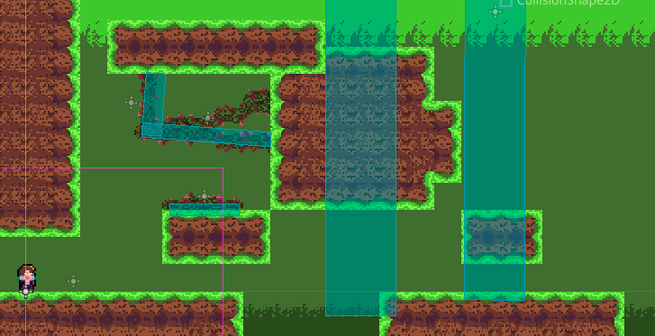

And here is a demonstration of their effects in-game:

Default camera limit:

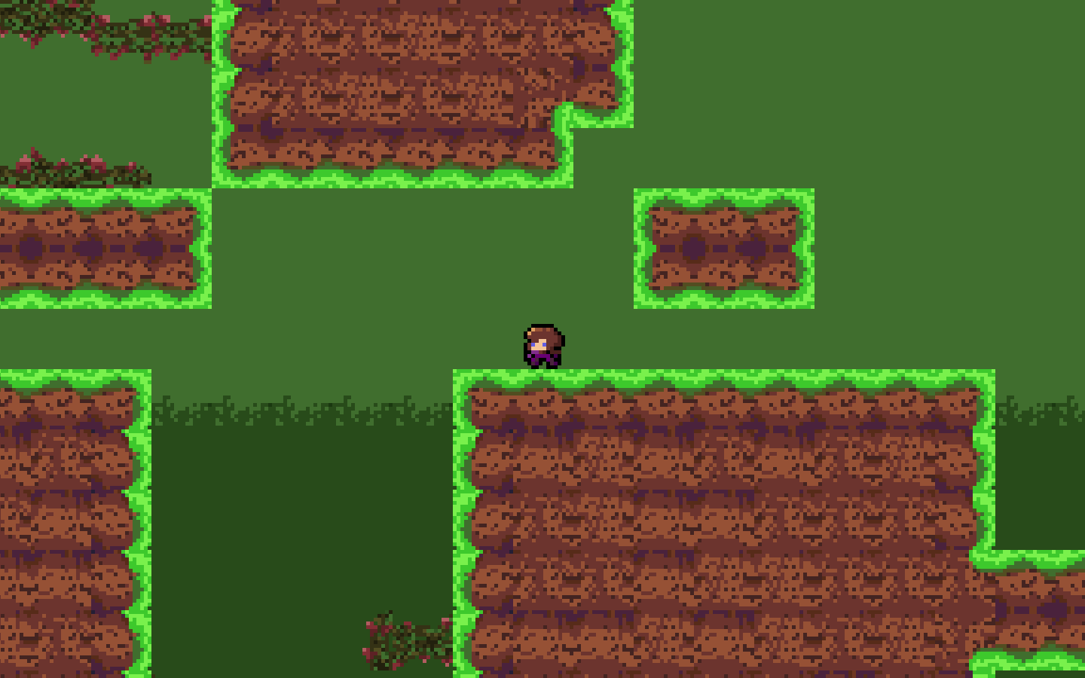

Altered limit:

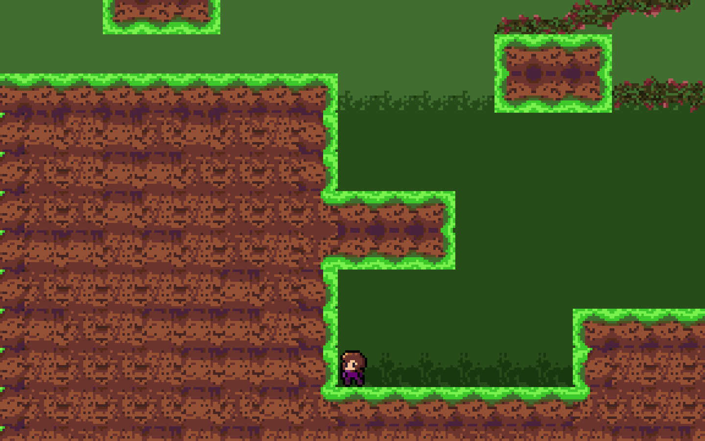

The orange line here represents the original camera limit; as you can see, it has decreased a little to display just enough of the screen for the player.

## Zone switching

Zone switching is a core feature of my game. I need the player to be able to explore vast territories, with several different rooms to run around in, but I can’t simply put the entire map onto one screen, that would cause performance issues and be a nightmare to work with. Instead, each room will have its own dedicated scene, allowing for me to create unique areas that simply need to be linked together. In order to do so, I have to first create a new subzone, so I did:

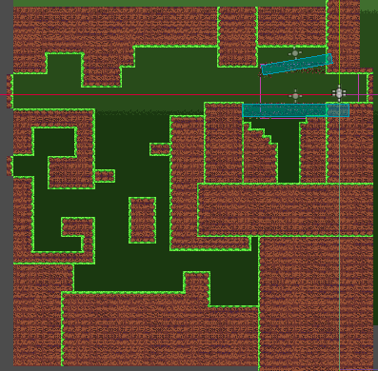

After this room was created, I needed to do a few things. Firstly, I had to ensure the player was instantiated in the scene upon loading it, which I had already done. I also needed to make sure that anything attached to the player in the main zone was also attached to the player in the new zone, so there were no discrepancies with attached nodes. To do so, I simply moved any necessary nodes from the Start Zone to the main player scene, so they would be universally attached to the player. Then, I had to make an area2D that would detect the player, and teleport them to the new scene. This was quite easy, as I just had to use the “get_tree().change_scene_to_file” function built in to Godot to load the new scene and replace the old one. Here is the code I ended up with:

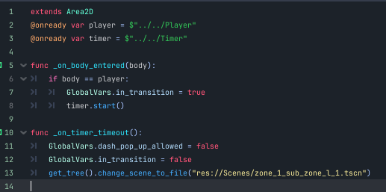

I added a timer because I wanted to later add loading screens in between loads, so this futureproofs that for when I get to that stage. The global variable “dash_pop_up_allowed” was something I added soon after this was all implemented and will be explained later.

This surprisingly worked smoothly, so I left it like this for now. I added a duplicate script, but to load the start zone, in the new area.

## Adding to the environment – part I

As I mentioned in the previous section, I added a variable called “dash_pop_up_allowed”. This is linked to one of the first ways I added to the environment, and also the game itself – locking away dash until the player reaches the tutorial for it. I created a little stone that looks like it is etched with writing and an image of a dash, and created an Area2D over the top of it that would activate a simple script when entered, that would teach the player how to dash. This is what the script looks like:

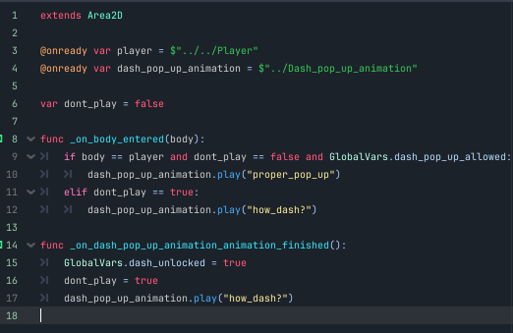

To explain the script, I will show step by step what happens in game:

Before entering:

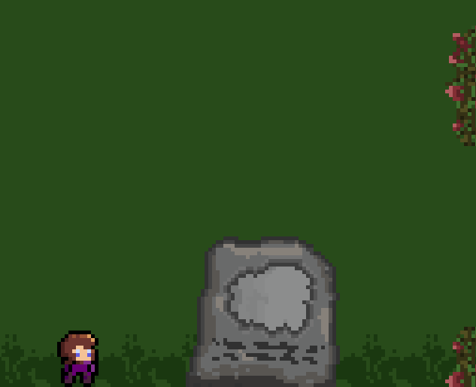

After entering:

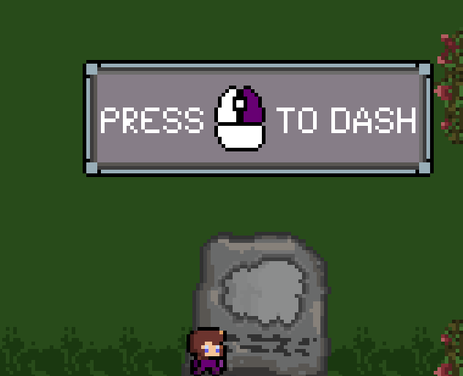

Between those two states, the sign undergoes a short animation that projects the screen up. The script also ensures that once the player has gone to the next subzone, it will not reactivate, so that backtracking will feel more natural as players will not need basic tutorials at that point.

I also created a similar system for combat – although I eventually decided I wanted a proper cutscene to occur where the player will be bequeathed a sword, so I left it for later.

The next step in making the environment feel more alive was simple in concept; add something living, or at least moving to the level (that doesn’t try to kill you). Immediately an idea of a bird sprang to mind. It isn’t the world’s most original idea, in fact there are myriad games which have these exact critters. However, I decided to move forth with the idea, and resulted in something that looked like this:

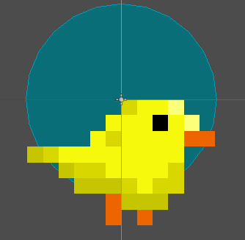

The code behind the bird is fairly short, simply checking if the player has entered the Area2D, and then making the bird shoot off in a random direction (determined using the randf() function, which generates a random float value between 0 and 1). It also flips the sprite when generated, and then again (if needed) when it flies away. See the code here:

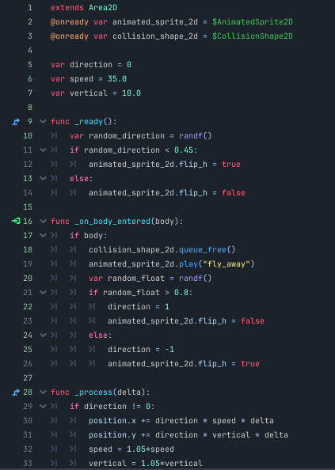

I then threw a few birds onto my level, which despite their simplicity added a lot of charm to the level.

The last part of the environment I implemented for the time being was simply a sign, which currently does not have any code so I will move on for now.

## Checkpoints & Respawn revamp

Heading back to backend functions, I decided to firstly implement a checkpoints system, where the player’s location is logged after touching certain zones so they would respawn there as opposed to the beginning of the level. Surprisingly, this was fairly simple. To begin with, I created three new global variables: the Boolean “respawn”, that checks if the player is currently respawning, the boolean “respawn_needed”, that checks if the player needs to respawn, and the Vector2 “respawn_point” that sets the player’s new spawn point. From there, I implemented these functions into the player:

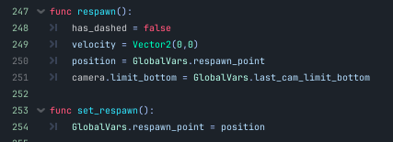

The ”respawn” function forces the player’s velocity to be stopped, and stops the dash function if they need to respawn whilst dashing – this stops possible bugs where players would be able to dash into something that kills them, and then respawning next to that object, and perpetually dying. It then sets the player’s position to the last noted respawn point; this means I need to take care in how I place respawn points inside my level, as in theory a player could skip respawn points if I don’t make them mandatory to pass through. It also sets the camera limit down to the last recorded limit, as there were some bugs if a player respawned in a zone with a different camera limit to where they died. I may need to duplicate this line for all variants of camera limit, but for now it works.

This function is attached to the spawn point areas, simply updating the need for a respawn.

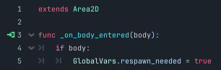

To call these functions, I decided to shift them into a new *_process()* function attached to the player, rather than in the *_physics_process()* function to keep my code from becoming mixed up – as these functions do not have any physics-related needs. Here is the code:

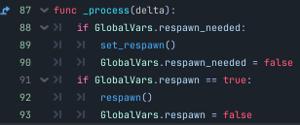

This code updates the player’s spawn point if needed, and then ensures that it does not update it again until necessary through line *90*. It also respawns the player if necessary, and again switches off the condition to respawn the player afterwards as seen in line *93*.

## Revamping the camera system

In my new subzone, I decided to change the camera system from the tutorial, as I felt the current system was a bit clunky and could be optimised. This required a small change, where rather than have small area2Ds determine when to change the camera limits, I would have large ones that determine the limits whilst the player is inside the area. This allowed for far less code to be written long-term, as there was no longer a need for a second area2D to reset the camera. Here is how this looks in the level editor:

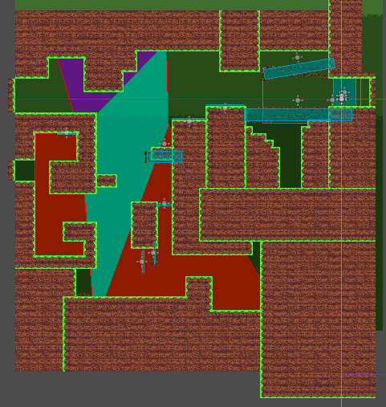

To clarify, the red/turquoise/purple areas are all areas (there are actually only two; godot just changes the colour of certain polygons inside the main polygon for easier viewing) where the camera changes. I left the parts outside the areas as they do not need to be altered from the default – but I also attached an “*_on_area_exited”* script to the large one through the centre to reset the camera when the player leaves the main camera zone.

## A new enemy

At this point, I decided that the game was severely lacking in the enemy department. Thankfully, I already had a gimmick idea for my next one: pathfinding. To do this, I watched some videos on the A* algorithm (see bibliography) to learn how I could approach implementing pathfinding into my game. However, after watching one video on the A* algorithm theory, I came across another that explained how to use in-built pathfinding nodes in godot itself, rendering my knowledge rather useless. But I still found it useful to understand the inner workings of the algorithm as the pathfinding nodes use the A* algorithm.

Firstly, I had to design my enemy. I struggled a little bit, but ended up making a slightly silly ghost:

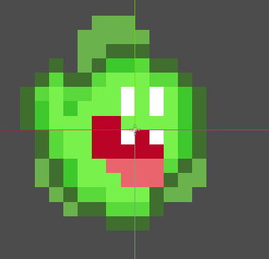

One nice thing about the ghost is that it was flying, so I could skip past the gravity and ray cast aspects of the goat and move straight on to the next feature: implementing the pathfinding. Thanks to the newfound nodes, was relatively simple. The code updates the ghost’s direction every frame (using a Vector2 value), and then checks if the player has entered the ghost’s range using an area2D attached to the ghost. If the player has entered the area, it runs this code:

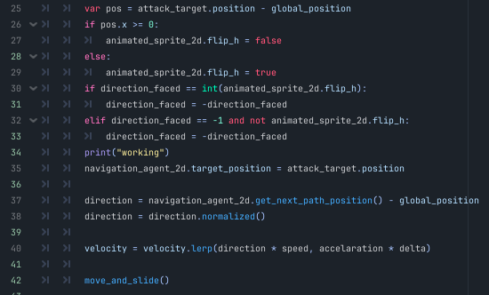

Lines 25-29 are taken from the goat’s code, and just check if the ghost needs to face in the other direction (to face the player). As I am writing this, I just realised that lines 30-33 don’t actually serve any purpose, so I have promptly removed them. After the print statement, the navigation node’s target gets updated to the attack target (the player’s) current position. It then sets the node’s direction to be towards the player, and proceeds to move it using a lerp function. Note: I currently don’t fully know what “lerp” means, so I will do some research on it in due time. Finally, line 42 covers the basic movement built into Godot.

I then applied the same “damaged” function (and the functions needed for it to work), as the goat so the player can fight and subsequently kill the ghost; and that was it! I may change the design of the ghost in future, but the base code will remain the same (or roughly the same) for this and future pathfinding enemies.

## SFX

At this point, I decided to dabble in sound effects to make my world feel a little more interactive. I created a dash sound effect using a microphone and garageband, and then got to work on implementing the sound in game. Firstly, I used an “AudioStreamPlayer2D” (quite the mouthful) to store the dash sound effect. Then, I attached the node to my player. Finally, I wrote it in as an onready variable in my player script, and called it to play (using the *.play()* function) when my player dashed. Despite this being a rather short endeavour, it will come in useful later down the line when I start implementing more sfx and music.

## Forge & Co. Interview

I decided now to host an interview with one of my stakeholders. After contacting each, Forge & Co. came back and let me know they were available for an interview, and so we booked in a quick meeting. After 5 minutes of discussion and playtesting, I extracted some one key point which I will transcribe here:

**Rory:** “There is no limit to the [jump]… right. So you’re gonna try and change that?”

**Me:** “Umm…”

**Rory:** “I think it would be better if you did. Like Hollow Knight, I want to be able to control the height of my jump.”

Well, it was clear what had to be done. I was a little hesitant, as I had initially tried and failed to implement such a system, but I thought a fresh pair of eyes may help me see how it could be done. And I was right!

The code is just one if statement:



What this does is check if the player has just released the jump button (therefore they must be mid-jump), and if they are not on the wall, still have their second jump and aren’t at the peak of their jump, the player’s velocity is slashed, and they begin to fall. I experimented with various numbers to affect the player’s Y velocity until eventually settling on 5, which gives the player much more control over their jump height, whilst not feeling forced when they release the button.

## NPC & Dialogue

The next thing I wanted to implement was something completely fresh: an NPC. This would be rather tricky to implement, and would involve not just an animated sprite with some script but also dialogue – something I would have to do a lot more research on, as I had no idea how to make it work to begin with.

It is here where I decided to implement a database (using SQLite), to hold all future dialogue in my game. To do so, I installed a Godot addon “Godot SQLite” that allows for SQLite integration. I also installed SQLite and DB Browser for SQLite as external software to manipulate my database with. See the addons below:

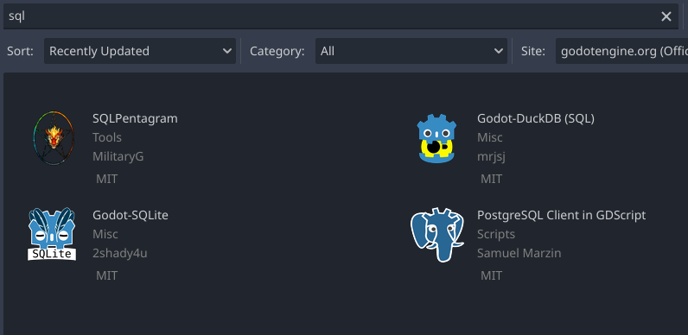

After downloading SQLite, the addon in Godot and DB browser for SQLite, I got to work creating my database. I decided to create one single database to hold all the dialogue, with tables for each unique character/ entity that needed dialogue. All dialogue in the tables is formatted by using primary keys attached to each line of dialogue, see here:

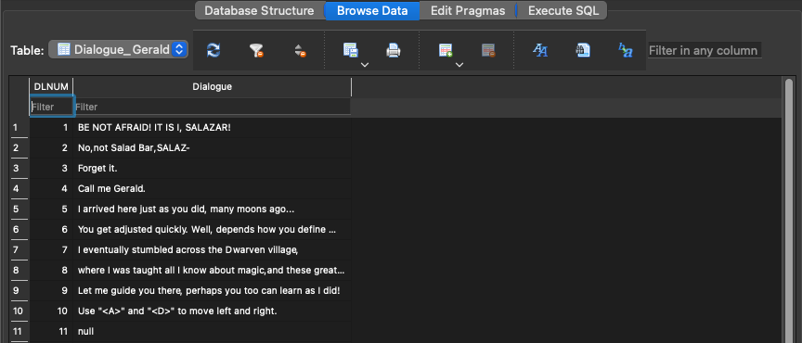

You may notice that on line 11 it contains a “null” value (stored as a json datatype). This is because I will implement the dialogue in a manner that it will loop across lines until it reaches said null value, at which point it will stop. This allows me to call lines of dialogue from any line I wish to, and will keep everything nice and contained, especially useful when there will be hundreds if not thousands of lines of dialogue stored here.

Before implementing any dialogue, I decided to make a quick UI display for the dialogue to be held in. After discussing with my stakeholders (namely JONDAL and RandomEF ltd) we decided that Undertale style dialogue boxes would be the ideal balance between consumer needs and my abilities, so I ended up creating this:

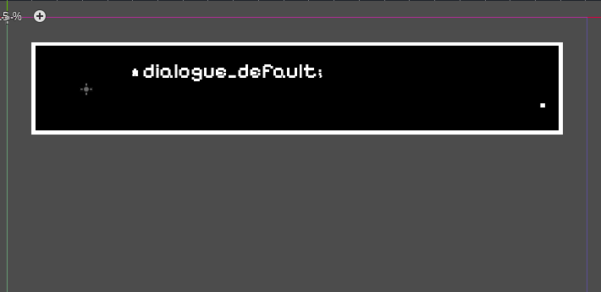

As you can see, there is a space to the left, which I will use to display the character currently talking, which will allow for multiple characters to interact if I need them to. The dialogue itself will be contained within the “*” and “.” symbols.

I decided now to completely finish the dialogue box aspect of the code, and created a set of functions to display text inside the box. Initially, I used a YouTube tutorial (see bibliography: Jon Topielski’s video) to understand how I might approach this system. To begin with, I wrote two functions using his method; one to hide the textbox, and one to show it:

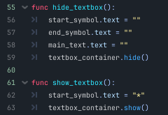

The *hide_textbox()* function resets the text inside the box as well as hiding the box, preparing it for when it is reused in future. The *show_textbox()* function sets the start_symbol to the “*”, and unhides the box.

Once these functions were completed, I had to do the trickier part, which was the code behind actually writing the text in. This time, the video I was following did not help at all, as he was using an older version of Godot, and the code he used did not work how I wanted it to and honestly I didn’t understand what the code did, which I wasn’t happy with. As an aside, one thing I did learn from this part of his video was this line of code here:

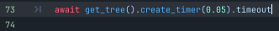

This is a far more efficient way of creating timers, being only one line long, and so from here I replaced all previous iterations of timers with this (unless the timers were activated using signals and were absolutely necessary) and then used this going forward.

I then worked on my own text algorithm, and ended up creating this:

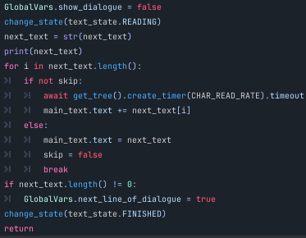

There’s a lot going on here, so let me break it down. Firstly, the global variable “show_dialogue” to false, as when it is true the *_process()* function calls this one; ultimately leading to issues when the text gets displayed, as this function would never stop getting called, when it should stop. The “change_state” function affects an enumerator which is pictured here:

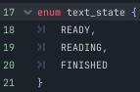

I had never used enumerators before, and actually learnt them from the aforementioned video – despite it not being exactly what I needed, it gave me a lot the foundations for dialogue, and taught me a lot of new functions and concepts. This is what the change_state function looks like:

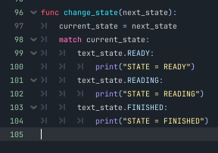

It prints the current state after making the change, which again is just used as a tool to debug.

The text_state enumerator is used primarily for the process function:

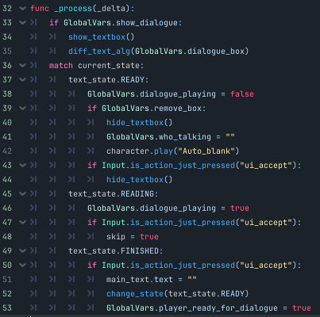

As you can see, I used a “match” statement to determine certain outcomes based on player state. If the text state is “READY”, it sets “dialogue_playing” to false, and then checks if it needs to remove the box. If it does, it hides the textbox and sets the “who_talking” variable to blank – this variable is used to determine which animated sprite to play next to the textbox. I added this after a glitch occurred, where the sprite would not leave the screen alongside the other text; this glitch ended up being very useful, as I used it as inspiration for how I would implement the UI. The bug in action:

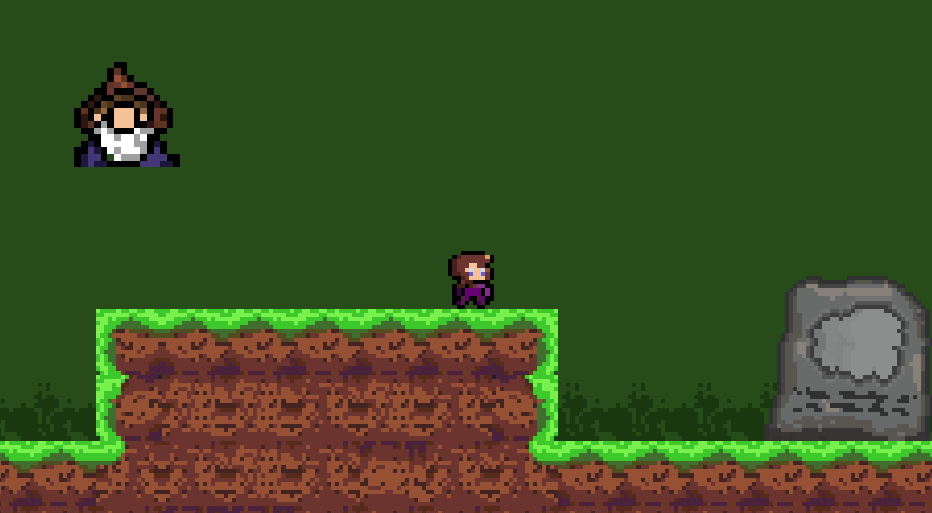

If the remove box check is false, it continually checks if the player presses “ui_accept” (space or enter on a standard keyboard, as far as I’m aware) and hides the textbox if so – this stops the last piece of dialogue perpetuating on screen. Then, if the text state is “READING”, dialogue_playing is set to true, and there is another if statement that repeats during the reading state, that checks for player input. If there is an input, “skip” is set to true, which skips the dialogue box to automatically fill with the currently playing dialogue, which I will cover in more detail momentarily. Finally, if the text state is “FINISHED”, it waits for the player’s input and then resets the text, changes the state back to READY and sets the player’s state to ready for dialogue.

Back to the previous code, the “next_text” line updates the next line of text to be displayed to be the next line in the database (only called if the next line is not “null”). The code that sets the next text will be shown in the database script. I also made the next line be printed in the console, to ensure there are no errors. This was particularly useful in establishing the issue with the “show_dialogue” issue mentioned earlier, as I could easily see what was happening.

The real meat and potatoes of the dialogue system comes in the for loop. The loop runs for i (each character) in the text’s length, and then does one of two things. If the player has not skipped the dialogue, a quick timer is created that lasts 0.03s, and then the dialogue’s text (main_text) gets the next character of the next text attached to it. However, if the player skips, the dialogue box’s text gets instantly turned into the next text, skip is returned to false to cancel out any errors and reset it for the next line, and it breaks the loop.

After the for loop is finished, the function checks if the next line of text exists (has a length greater than zero), and if it is larger than 0 (despite it being !=, the length can never be negative so it functions the same, I just prefer this syntax) then it starts everything over again using the global variable “next_line_of_dialogue”, and setting it to true, to make the function run again.

Finally, it sets the text state to FINISHED, and that concludes that. This function is infinitely scalable, and so I can use it for all future pieces of dialogue, as it simply uses whatever data it receives regardless of origin.

Once this was all finished, I got to work on importing the database, and creating the dialogue system. The code to initially import the database was only a few lines long:

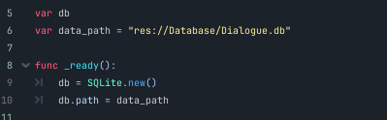

The “db” variable is simply a variable that will handle the database in Godot, and the “data_path” is just the directory where the database (stored in SQLite) is stored. The ready function assigns the SQLite addon to the database, and then sets the database’s path to the correct file directory.

The next functions link to the dialogue_box quite closely, so bear with me if I reference the previous functions whilst explaining the new ones; I will try and make this as easy as I can to read, but these are very tightly knit scripts so you may need to refer to the past few pages to fully understand how this works.

This is the first function I created, the *_process()* function:

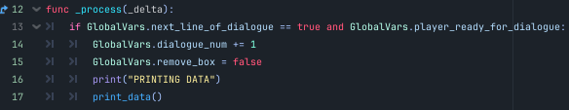

This function checks if the dialogue should play or not based on the two variables you can see above, and then if it does it executes the following: updates the dialogue number to increment by 1 (this will be used to reference the primary key in the database), sets the variable that hides the box to false so it is displayed, and calls the function “print_data”, which I will now show. It, as with much of my current debug mode code, also has a print statement to show when this all executes.

The print_data function is what accesses the database, reads the selected line, and returns it to be used as the next_text for the dialogue box. I will show the whole function and then zoom in on to chunks to explain how it all works:

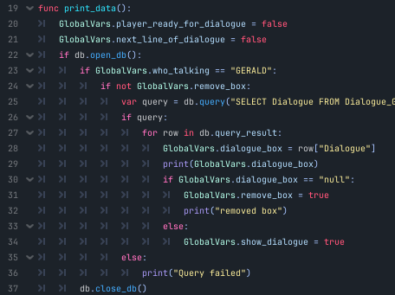

To begin with, the function stops itself from incessantly being called by setting the two variables above to false – both of these are used as checks for various scripts, with the first being primarily used for the player-related scripts to disable aspects of the player such as movement whilst dialogue is playing, and then the other is used in the current scripts as a more localised variable (still global as it needs to be accessed across scripts).

It then checks if the database can be opened; this is fairly arbitrary as it will now never not open, but it is still useful for futureproofing in the case of adding extra databases here, or random bugs.

After this, it checks the “who_talking” variable – at this stage, I only have Gerald, but this will come in incredibly useful when I have many NPCs and interactable entities, as they will need different tables to be accessed.

It then performs a check on whether the box is removed or not, and if it is not removed, then it continues.

The next line is one of the most complex single lines I’ve written thus far, simply because it does not solely use GDscript, but rather SQL. Below is the full line:



The SQL statement selects the dialogue column from (in this case) Gerald’s dialogue table, where the DLNUM (the primary key) is equal to “%d;” – this is an arbitrary value that is replaced at the end of the statement with the global variable “dialogue_num”. To give an example, if the dialogue number is set to begin at 5, the “%d;” will become “5”. This SQL statement is then injected into the database using the SQLite addon function “db.query”, and the query is executed.



Then, if the query executes, it executes a for loop. This iterates through the “row”s in the query, and updates the dialogue_box’s text to be the row, but only the “dialogue” portion. Refer to the example of the database before to understand what I mean a little better if there is any confusion. There is of course a print statement to debug, this is customary at this point.

The next line, the if statement, is very important; it checks if the dialogue is equal to “null”, and if so, it removes the box. If not, it shows the box. This is a small piece of the code but is the main way I will have to implement all future dialogue – as I mentioned earlier, if you look at the Gerald table, there are chunks of dialogue broken up by “null” values. In other words, this allows for all my dialogue to be stored in one table and prevents me needing to put individual parameters (e.g., from DLNUM == 19 to DLNUM == 24) for each line of dialogue.

It then closes the database when it is not needed.

That’s it! I had finally implemented the dialogue box. I showed it to Jonathan (from JONDAL), and he really appreciated the way you could skip dialogue, and the easy flow of text. After all my hard work, I was very satisfied with the dialogue system, and I am beyond pleased that the stakeholders were happy with it too – I don’t want to look at another database for at least a few more functions.

Now on to the NPC – this was far simpler to do, and I simply created an animated sprite for Gerald, and that was pretty much it. I also attached the database scene to him, so I could add dialogue to him. I also attached two area2Ds to him, with simple scripts to flip his sprite to face the player when they pass him.

To make Gerald have dialogue, I created separate area2D nodes in the StartZone scene to activate his dialogue – I did it this way as if they were attached to Gerald, he would only have one set of dialogue he could say, and it also let me activate his dialogue even when he was off screen.

This is the template I created for the dialogue code:

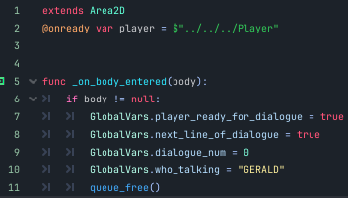

This imports the player, as I initially planned to check if the body was equal to the player, however I ended up just changing it to null. I flipped between the two methods a lot, so it still may be changed in future. It then updates the two important bools to decide what state the player is in, and activates the dialogue scripts, and then sets the dialogue start number to 0 (this can be changed to any number I want to access whichever piece of dialogue I need), and then updates who_talking to “Gerald” (again, this can be altered to whoever I want it to be). It then frees itself from the queue, so it does not reactivate unless the scene is reloaded – this will cause issues in the future, but currently I just needed it to be implemented so the stakeholders can see how everything is working.

Once this was done, I showed Eshan (RandomEF ltd) the finished NPC, as it was now, which looks like this:



In that clip, I tried to show all the different parts of dialogue working, such as the continual writing, the waiting for user input, and the skip. Despite the clip’s lack of showing this, every time the dialogue was reset, or skipped, that was me pressing the enter key.

## UI - lives

As I mentioned in the previous section, I ran into a bug with the dialogue display that ended up giving me an idea on how to implement the dialogue. The way I used this was to create a *CanvasLayer* scene (that would draw over other scenes if added to them), and created some hearts that would represent the player’s lives. As most of my stakeholders are familiar with Hollow Knight, I decided to place the lives in the top left of the screen – the same place that Hollow Knight, and many other games akin to it, place their lives. This resulted in this:

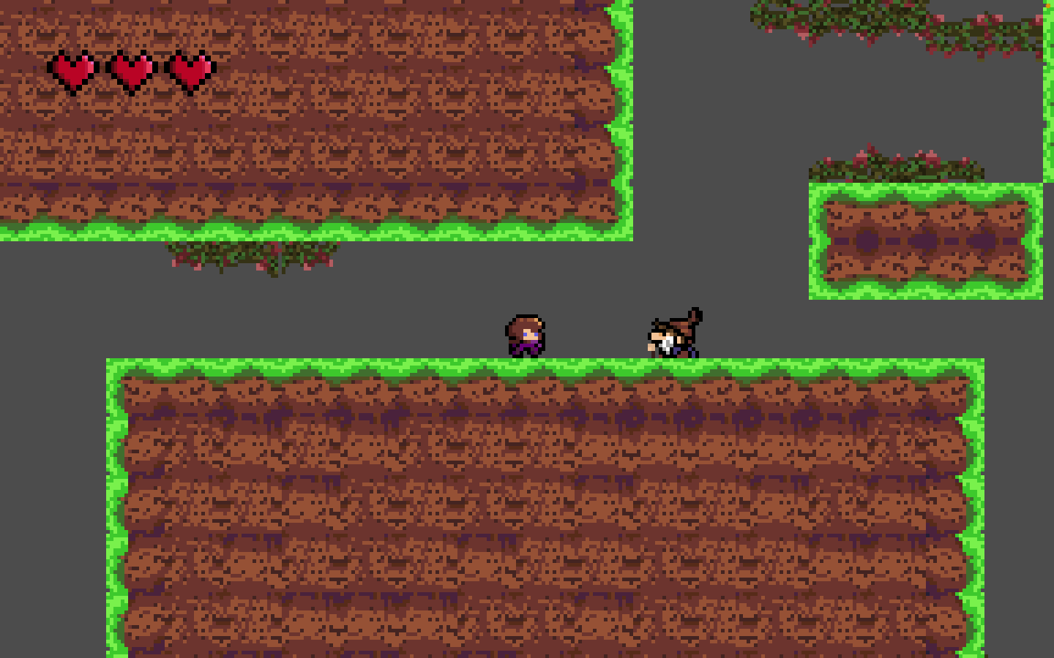

Ignore the background – I removed the background as many stakeholders (particularly Forge & Co. and JONDAL) did not like the plain green colours, this will get updated after I implement some features stakeholders have wanted for longer. You can also see the hearts in the previous GIF; this is just because I only realised I could add videos here after adding the hearts!

Once I had the basic heart sprites in place, I had to create a way to display the player taking damage through the hearts. To do so, I first created an animation to show the heart breaking, and a sprite to replace the full heart with an empty one. Then, I created a template node to contain all the necessary sprites, and moved all the nodes around so each heart was contained in its own node despite having various sprites (with a mixture of animated sprites and sprite2Ds). I then imported the sprites into a script attached to the canvasLayer and began coding the display. Firstly, I created a *_ready()* script that would update the player’s lives when they enter a new area, and initially boot up the game:

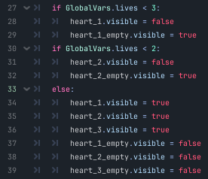

This code is a boolean bonanza but works well. I may improve it further in future to make it more efficient, but for now I decided to move on for the sake of time.

I then created a ­*_process()* function that would update the hearts every frame. A tad inefficient, as it doesn’t necessarily need to run every frame, but it was the quickest way to implement it and wouldn’t cause any issues for the foreseeable future anyways. This is the bulk of the function:

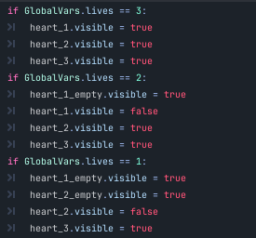

This checks the player’s lives, and updates the hearts accordingly. There is also a part of the function that hides all the hearts if dialogue is playing, to ensure there is no overlap for a smoother experience.

Finally, I wrote a function to handle animations, which I will explain below:

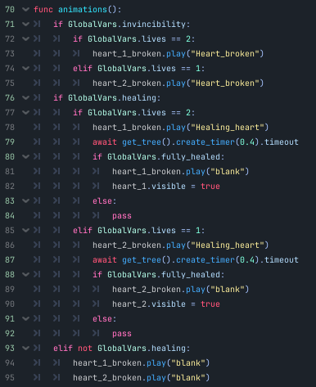

Lines 71-75 handle the player getting damaged; if the player gets damaged, they become invincible for a moment to allow them to escape, and this script just checks if the player is invincible, and if so, updates the heart lost to break.

Then, lines 76-92 deal with healing. The first if statement checks if the player is healing, and then if so there is an if/ elif pair to check how many lives the player is currently on; there are only two possibilities with 3 lives, as you cannot heal beyond 3 lives so they must be on 1 or 2. Within the identical if statements (lives == 2 and lives == 1) They play the healing heart animation to indicate to the player which heart is healing, and then starts a timer for 0.4s – the same amount of time it should take the player to heal – and then checks if the heart is healed, and stops the animation and replaces it with the fully healed heart. If the player stops healing during the animation, it switches to the final elif (lines 93-95) which stops all animations. Due to the previously mentioned timer, the hearts do not fill up if the player cancels healing at any point before fully healing.

## Potions – healing revamp

Alongside implementing the hearts, I decided to revamp the healing system. Delta & Sons did not think the current system was challenging enough, as they could just heal at any point; making the player essentially invincible if they continually healed.

To counter this, I suggested a potions system, where the player can only heal if they have a healing potion to do so, which the stakeholders unanimously agreed would be a good idea to at the very least test.

Firstly, I created a basic potion sprite, that I would use in the UI to display the potions. Then, I created a template node for the potion, to which I attached a Sprite2D node and a label node for the sprite and counter respectively. The counter just displays how many potions the player has at a given moment. This resulted in this:

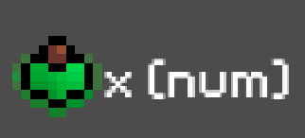

It looks a little cramped there, but once the (num) is switched to a number, it looks much smoother; the (num) is just a placeholder value.

Implementing the potions involved updating the UI script that had the hearts on it to include the display of the potions, where I added these lines into the *_process()* function:

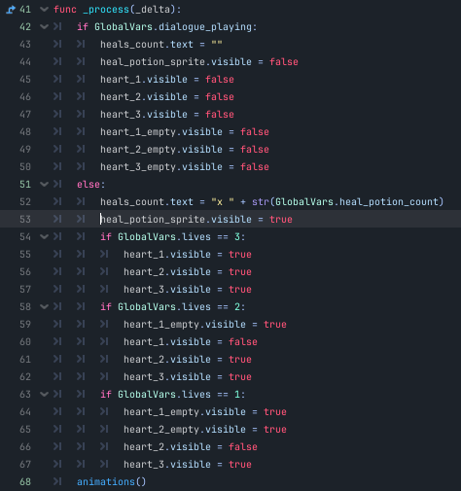



These just hide the potion UI if dialogue is playing, and shows the sprite alongside a repeatedly updated counter of the player’s potions. I also made a Global variable to store the player’s current potion count.

After this, I had to alter the healing code so the player could only heal if they had a potion, which resulted in this:



This code just adds a condition check to make sure the potion count is above 0. I then updated the code that executes after fully healing:

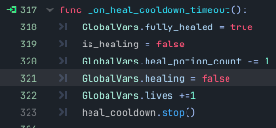

This sets fully_healed to true, which indicates to the heart animation script that it should stop playing the heal animation and replace the blank sprite with a fully healed one. As for the potions, it takes away one potion after it is used.

## Chest(s)

After implementing the potions, I realised there was no way for the player to actually get any potions, so I needed to change this. I decided that a chest system would be a good way to do so, as I could scatter them around the map for the player to intermittently get.

To do so, I first created two chest sprites – one to show it is closed, and another to show it open.

I then created a Node2D scene to hold all the necessary nodes for the chests; two sprites for the closed and opened states, an area2D to allow the player to interact with the chest, and an audio node to let me add a sound effect to the chest.

I then attached a script to the Area2D node, to control the state of the chest, and to get it to display a piece of “dialogue” (although more of a message) to the player.

Before any functions, I created two variables in the script; one that determines if the chest can be opened which is set to true on first loading, and another that checks if the player is in range to interact with the chest which is set to false on load.

In the ­*_ready()­* function, I activate the closed sprite and hide the open one.

In the *_process()* function, I do a little bit more:

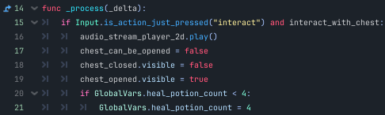

Here, it checks if the player is in range of the chest, and subsequently if they have pressed the interact key (default set to “E” on a standard keyboard).

If the player does interact, it then does the following: plays the sound effect, stops the player from being able to open the chest afterwards, closes the chest (by switching the sprites) and if the player has no potions, gives the player 4 potions. I will, likely change this in future, as it is a bit poor to only give the potions to the player if they have none.

To handle dialogue, I copied the script from the other dialogue activation scripts and altered it to work for the chests (which is a new table in the database):

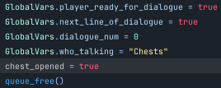

This links to a new part of the database script, which is again just a copy of what came before, altered to work for the chests. I will not attach it here, as it is rather chunky and would merely waste space; if you do wish to see it, feel free to check the full code at the end of the document, or refer to the prior display of it in the initial database implementation; it’s identical besides the SQL query (swap Gerald with Chests) and a couple small bits relating to the chests.

Finally, there is this code:

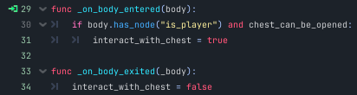

This is attached to the Area2D with signals, and just updates whether the player can interact with the chest or not depending on if they are inside the area.

## Map expansion

At this point I decided to take a break from adding new features, and I decided to expand my map – after all, the main selling point of a metroidvania is a large, expansive region for the player to explore, so I need to build that region. Here is a rough sketch I mocked up to display my idea of how the map should look, which I used here to keep a sense of continuity in the rooms I made, and I will use later to implement an in-game map:

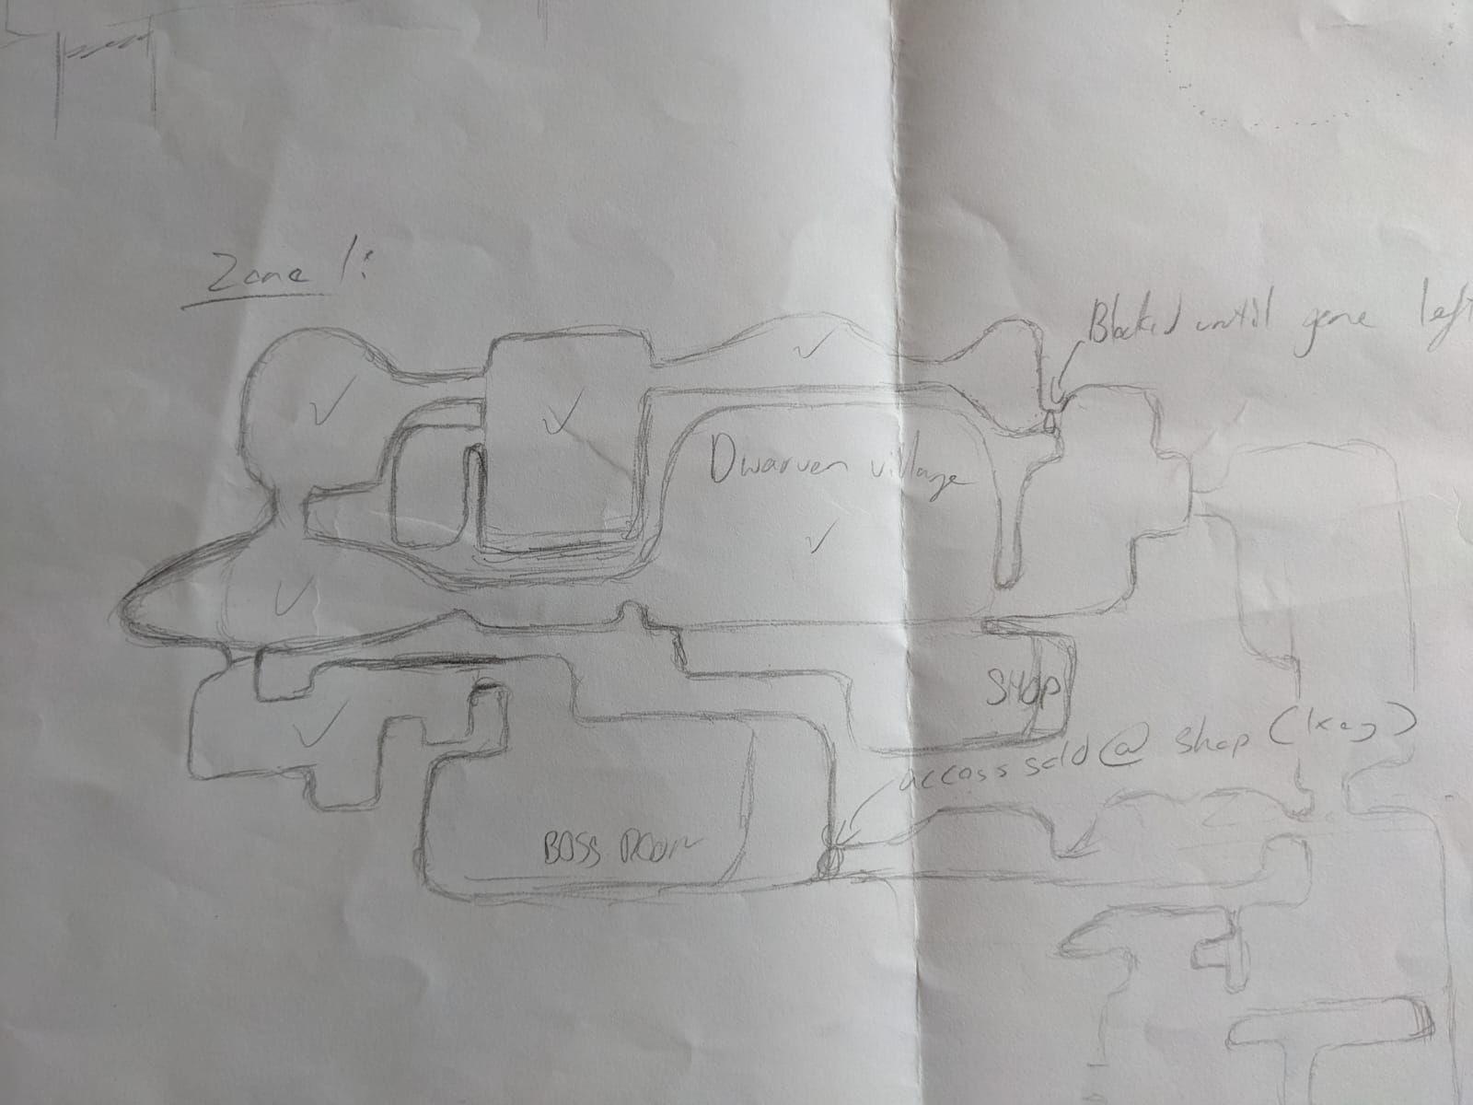

A majority of the sketch there is zone 1, but I made an unfinished mock-up of zone 2 and how it will interact with zone 1. After this sketch was finished, I simply created the rooms roughly in the shape and scale of what is on the sketch. They are relatively accurate, so the in-game map will make sense, however I gave myself some leeway as to not take too long to create.

## Lighting

After creating the main map of zone 1, I decided to add lighting to my game. Godot has its own lighting system, comprised of a few different nodes, however the main two I used were *CanvasModulate* and *PointLight2D.* The canvas modulate node modifies a layer of colour placed over the scene, which I used to darken the entire scene, and then the point light lights up an area from a point (you have to add a texture for it to apply the shader; I used Godot’s default circle gradient texture to initially implement it). I attached my point light to the player, so wherever they went they would light up entities/ map in close proximity to them, which looks like this in game:

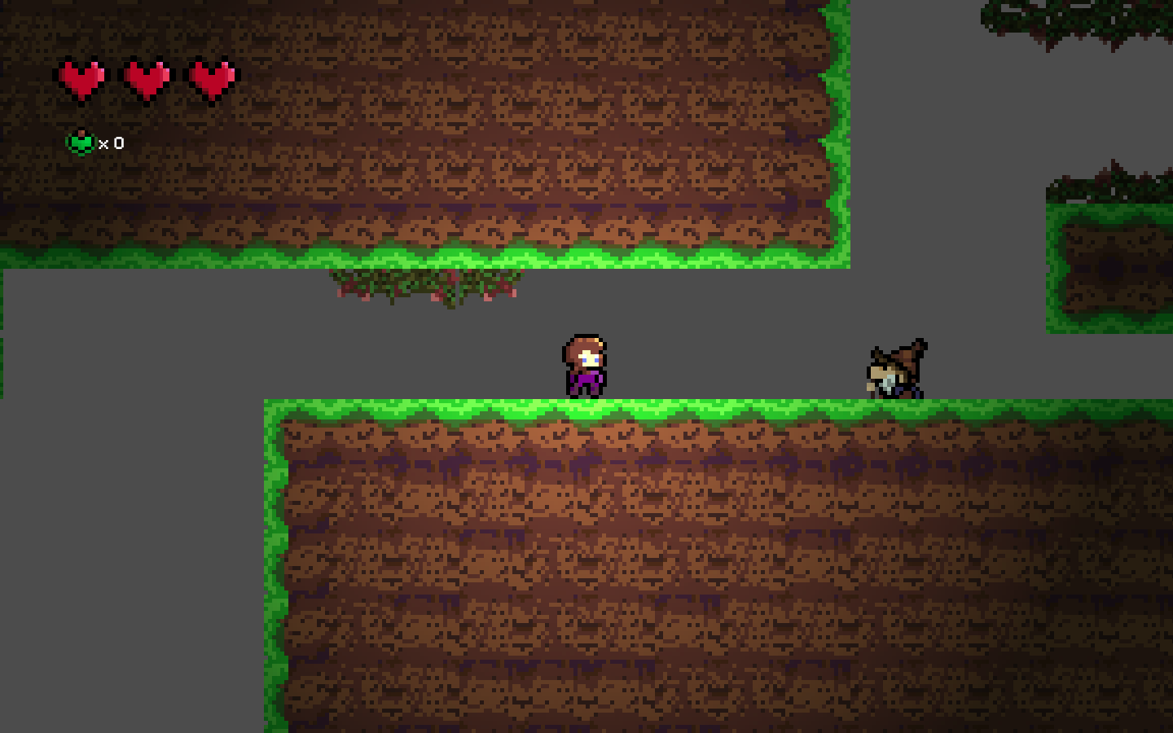

As you can see, everything not directly in range of the player is in shadow, and everything in radius of the lighting gradient gets increasingly lighter. I also made it so that the lighting will only affect the layer of the player, and one above and below, so the backgrounds can remain unaffected by the lighting system and look further away. After implementing this into the first scene, I copied the canvas modulate node into all other rooms, which enabled the lighting system to work in all areas. I also decided that for zone 1 I would hue shift the modulation to be slightly green, as it is a grassy area. It isn’t really noticeable, but in accordance to colour theory will look more natural than using jet black with a low alpha value (alpha being transparency, if you are not aware).

# Bibliography:

*Brackeys: How to code in Godot - GDScript tutorial* [*https://www.youtube.com/watch?v=e1zJS31tr88*](https://www.youtube.com/watch?v=e1zJS31tr88)

*Brackeys: How to make a Video Game – Beginner Godot tutorial*

[*https://www.youtube.com/watch?v=LOhfqjmasi0*](https://www.youtube.com/watch?v=LOhfqjmasi0)

*PlayWithFurcifer: How to shader (fast) - using Godot engine*

[*https://www.youtube.com/watch?v=1pJyYtBAHks*](https://www.youtube.com/watch?v=1pJyYtBAHks)

*Sebastian Lague: A* Pathfinding (EO1: Algorithm Explanation)*

[*https://www.youtube.com/watch?v=-L-WgKMFuhE*](https://www.youtube.com/watch?v=-L-WgKMFuhE)

*Abra: 2D navigation/pathfinding in Godot 4 – a quick tutorial*

[*https://www.youtube.com/watch?v=AGHtw8__oqw*](https://www.youtube.com/watch?v=AGHtw8__oqw)

*Google Fonts*

[*https://fonts.google.com/*](https://fonts.google.com/)

*Pixelify font (used in game)*

[*https://fonts.google.com/specimen/Pixelify+Sans?preview.text=Press%20%5BE%5D%20to%20interact&preview.size=12&query=pixel*](https://fonts.google.com/specimen/Pixelify+Sans?preview.text=Press%20%5BE%5D%20to%20interact&preview.size=12&query=pixel)

*Jon Topielski: How to make a Simple RPG Textbox in Godot*

[*https://www.youtube.com/watch?v=QEHOiORnXIk&t=611s*](https://www.youtube.com/watch?v=QEHOiORnXIk&t=611s)